**Downloading The Data**

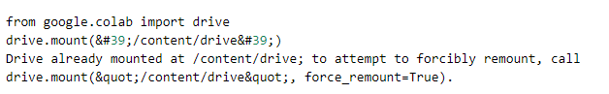

cd /content/drive/MyDrive/ibm/Digital Naturalist Dataset/Digital Naturalist

Dataset

/content/drive/MyDrive/ibm/Digital Naturalist Dataset/Digital Naturalist

Dataset

ls

Bird/ Flower/ Mammal/

**Data Augmantation**

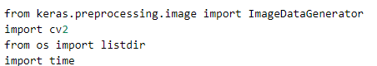

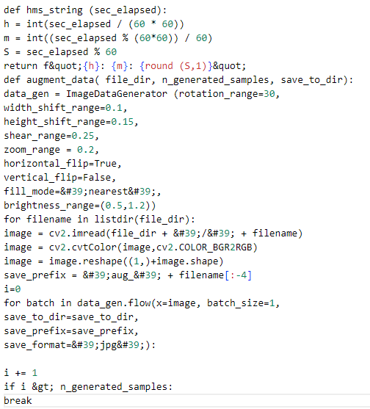

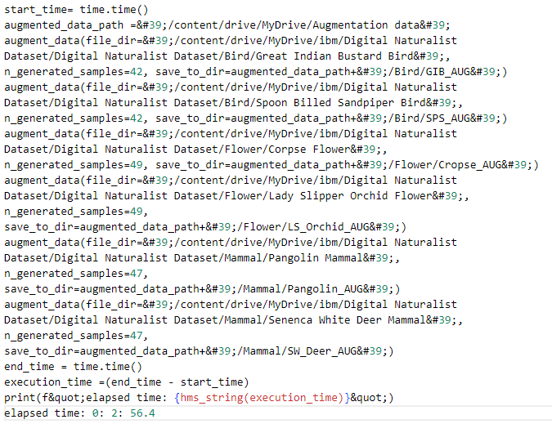

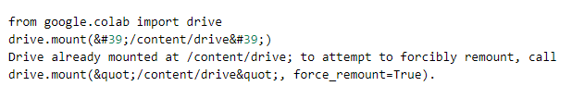

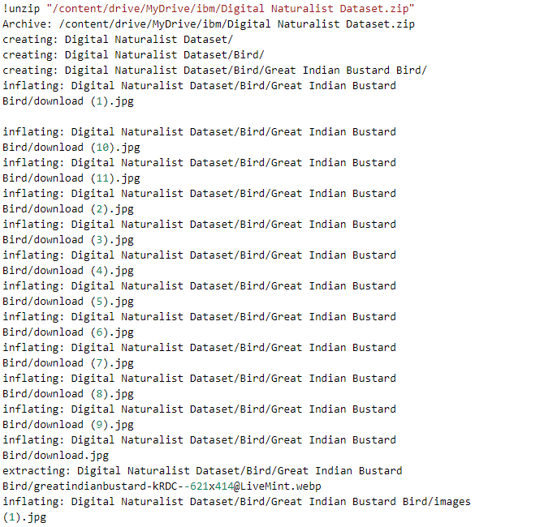

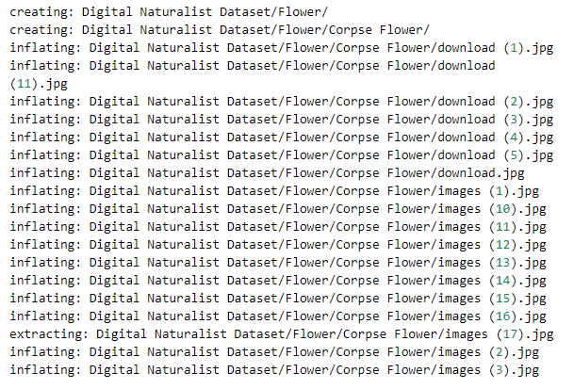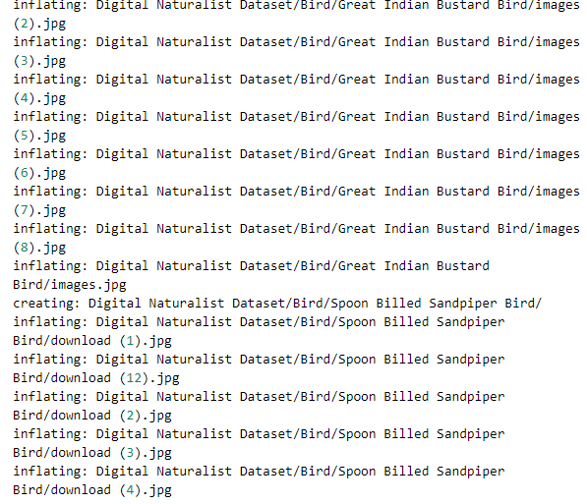

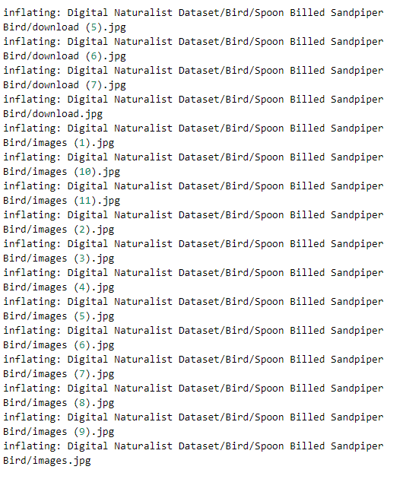

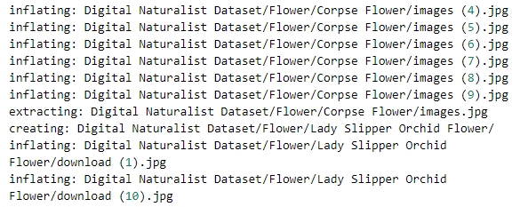

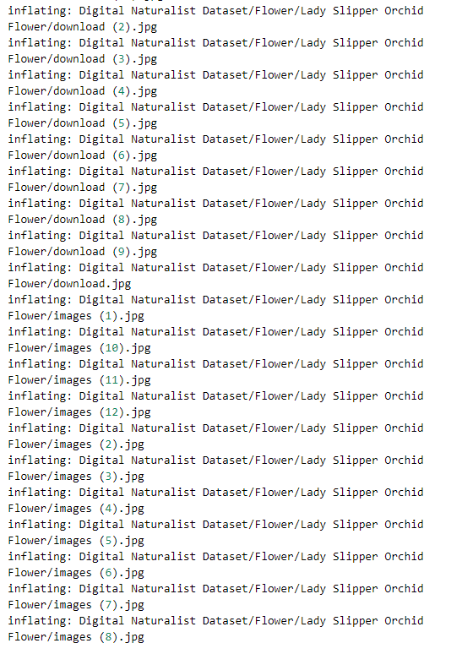

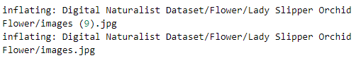

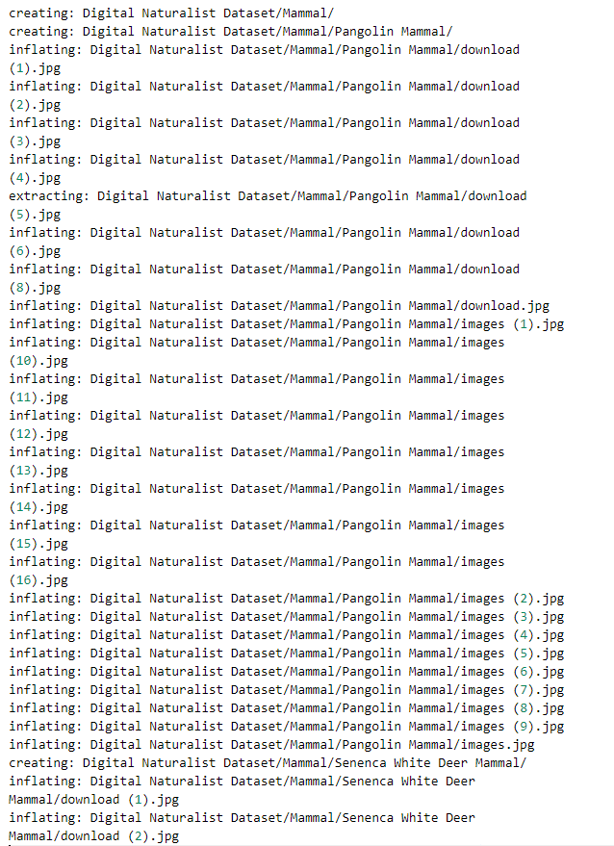

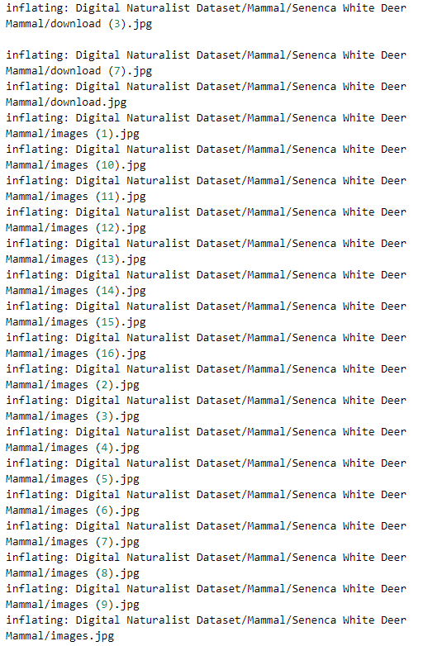

cd /content/Digital Naturalist Dataset

/content/Digital Naturalist Dataset

ls

Bird/ Flower/ Mammal/

**DataAugmantation**

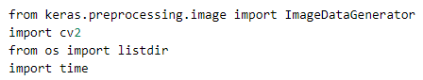

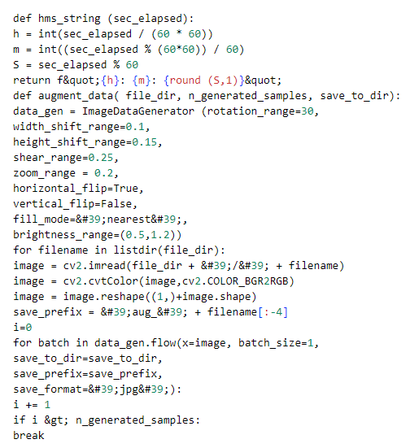



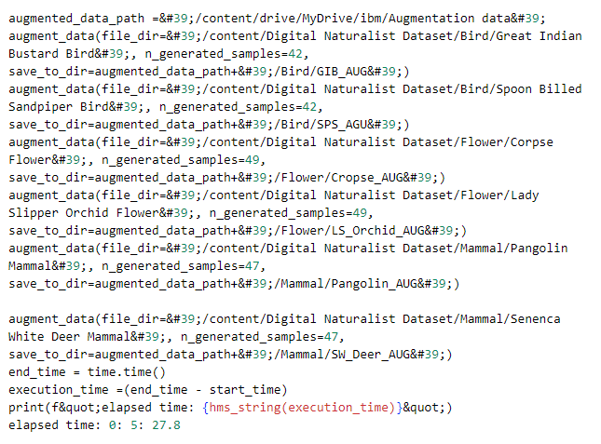

**Libraries**

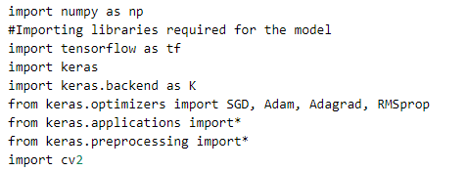

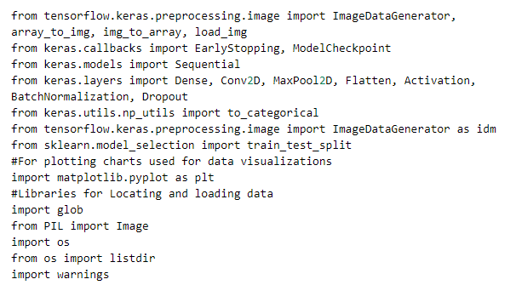

**Make a list of path to all folders where you have the data**

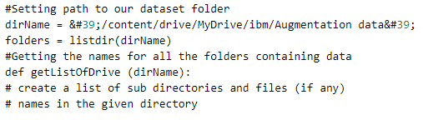

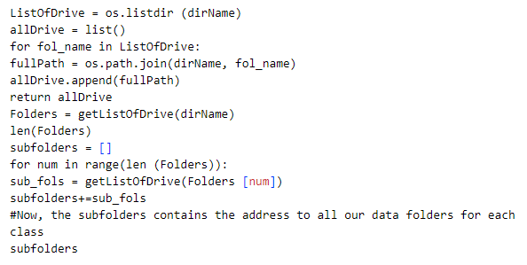

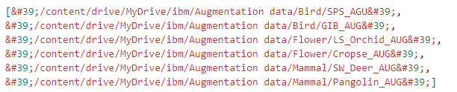

**Loading images into machine understandable data**

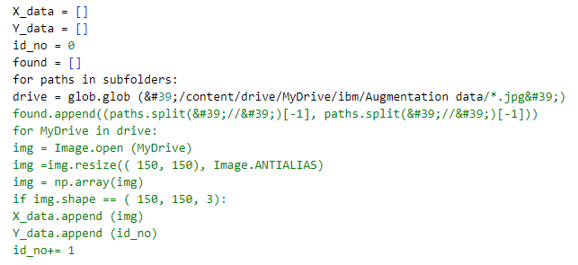

**Data Spliting into Train and Test**

